JSP Architecture Design

数字校园

V 1.1

Eric CHEN
Tech Lead

Sep 10, 2001

Document Control

Change Record
Date | Author | Version | Change Reference
9/7/2001 | Eric CHEN | 1.0
9/10/2001 | Eric CHEN | 1.1 | Add some directories

Reviewers
Date | Name | Position
9/10/2001 | Eric CHEN | Tech Lead
9/10/2001 | Erin WANG | Project manager
9/10/2001 | Jack HUANG | Architecture
9/10/2001 | Robin LIU | Architecture
9/10/2001 | Qian XIANG | DV
9/10/2001 | Shui WANG | DV
9/10/2001 | Zhoguo ZHENG | DV

Approved By
Name | Position | Signature | Date
The copy numbers referenced above should be written into the Copy Number space on the cover of each distributed copy. If the document is not controlled, you can delete this table and the Copy Number label from the cover page.

CONTENTS
Document Control 2
Change Record 2
Reviewers 2
Approved By 2
Overview 4
Directory lists 4
Architecture 5
Architecture of whole directory 5
Architecture of teacher directory 6
Architecture of student directory 7
Architecture of admin directory 7
Architecture of share directory 8
Architecture of common directory 8
Architecture of eschooldoc directory 8
Architecture of tlds directory 9
Architecture of help directory 9
Contrast 9
Tag List 11

Overview
该文件旨在描述虚拟电子学校中的JSP文件架构。

说明：
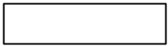 代表文件夹（Directory）
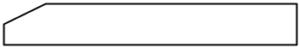 代表文件（File）
T代表教师；S代表学生；A 代表管理员。
特别注意：在所有时间输入时间的地方均要有注释：“请按此格式输入19990901，代表1999年9月1日”。在页面描述中不再描述

Directory lists
No | Name | Catalog | Father | Depict
1 | root | 0 |  | 存放所有JSP文件的根目录
2 | teacher | 1 | 1 | 存放和教师相关的JSP文件的目录
3 | student | 1 | 1 | 存放和学生相关的JSP文件的目录
4 | admin | 1 | 1 | 存放和管理员相关的JSP文件的目录
5 | common | 1 | 1 | 教师、学生和管理员共用的JSP文件目录
6 | share | 1 | 1 | 教师和学生共用JSP文件的存放目录
7 | help | 1 | 1 | 存放和帮助有关的HTML文件的目录
8 | tlds | 1 | 1 | 存放标签文件（taglib.tld）的目录
9 | data | 2 | 4 | 存放管理员的资料管理JSP
10 | user | 2 | 4 | 存放管理员的用户管理JSP
11 | course | 2 | 4 | 存放管理员的课程管理JSP
12 | test | 2 | 3 | 存放学生的考试JSP
13 | homework | 2 | 3 | 存放学生的作业JSP
14 | others | 2 | 3 | 存放学生的其他JSP
15 | test | 2 | 2 | 存放教师的考试JSP
16 | others | 2 | 2 | 存放教师的考试以外JSP
17 | common | 2 | 2 | 存放教师的test和others共用的JSP
18 | common | 3 | 15 | 存放教师的test下文件的共用JSP
19 | common | 3 | 16 | 存放教师的others下文件的共用JSP
20 | image | 1 | 1 | 图片存放
21 | eschooldoc | 1 | 1 | 上传资料的存放的地方
22 | bbs | 1 | 1 | 存放论坛JSP
23 | chartroom | 1 | 1 | 存放聊天室JSP
24 | mail | 1 | 1 | 存放邮件相关的JSP文件
25 | test | 2 | 21 | 存放上传的考试文件
26 | homework | 2 | 21 | 存放上传的作业文件
27 | listening | 2 | 21 | 存放上传的听力文件
28 | exercise | 2 | 21 | 存放上传的练习文件
29 | selftest | 2 | 21 | 存放上传的自测文件
30 | preparation | 2 | 21 | 存放上传的预习文件
31 | review | 2 | 21 | 存放上传的复习文件
32 | teacher | 3 | 25 | 存放教师上传的考试文件
33 | student | 3 | 25 | 存放学生上传的考试文件
34 | teacher | 3 | 26 | 存放教师上传的作业文件
35 | student | 3 | 26 | 存放学生上传的作业文件

Architecture

Architecture of whole directory
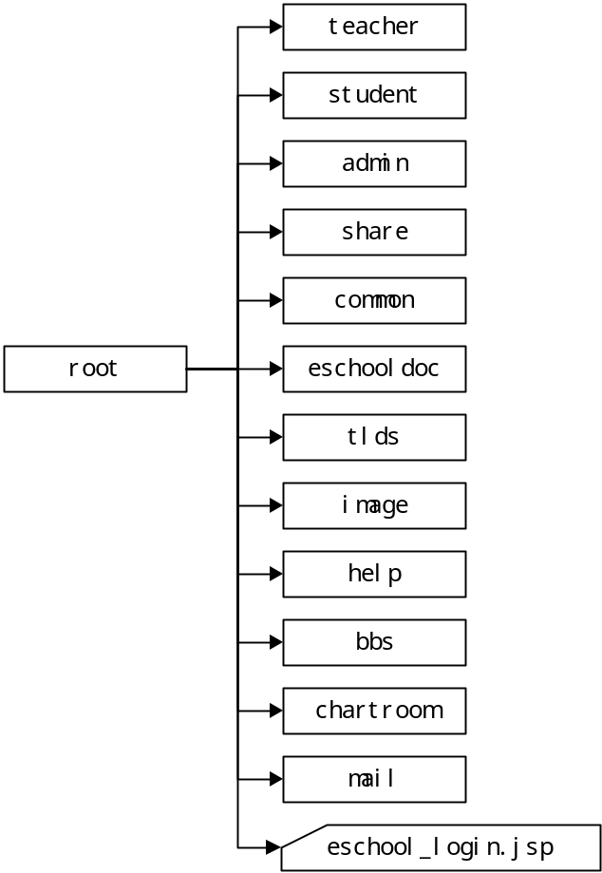

Architecture of teacher directory

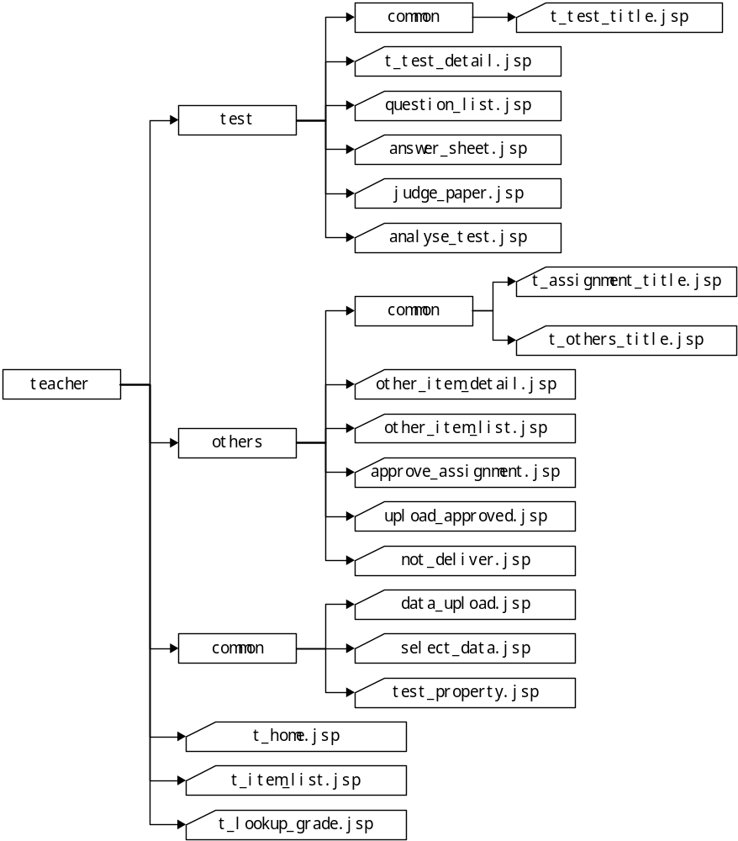

Architecture of student directory
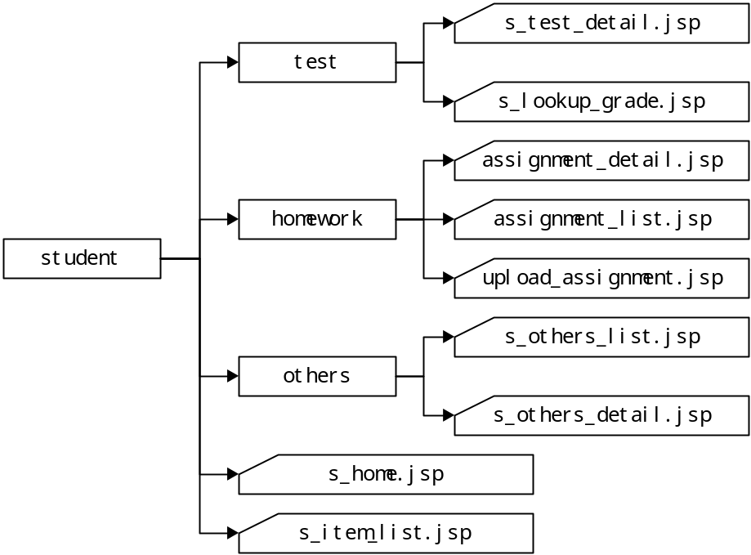

Architecture of admin directory
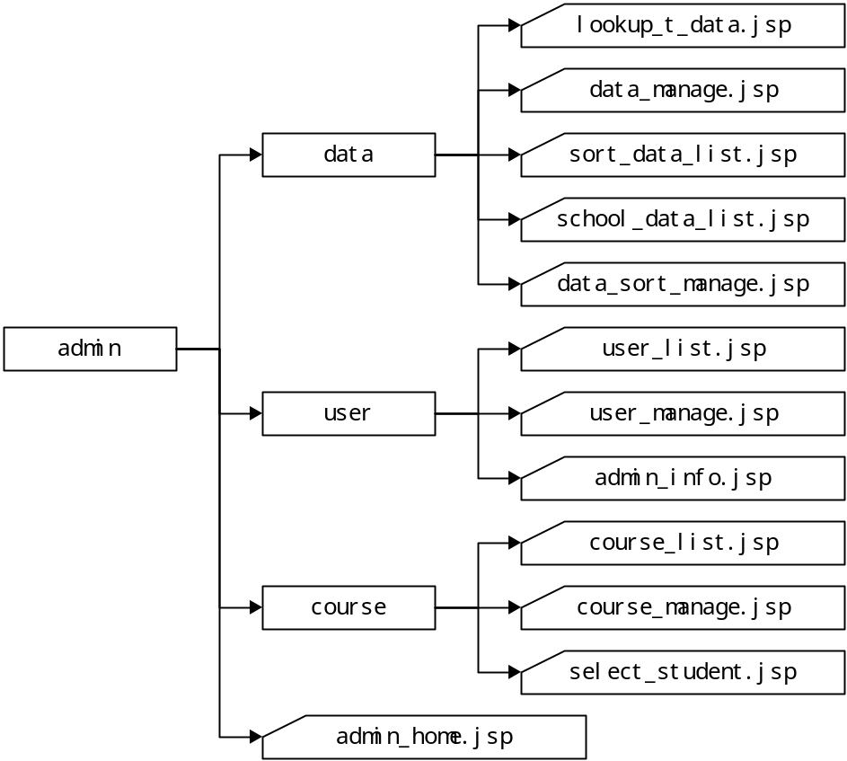

Architecture of share directory
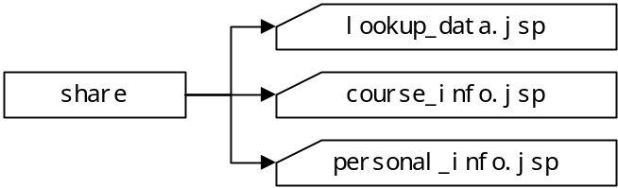

Architecture of common directory
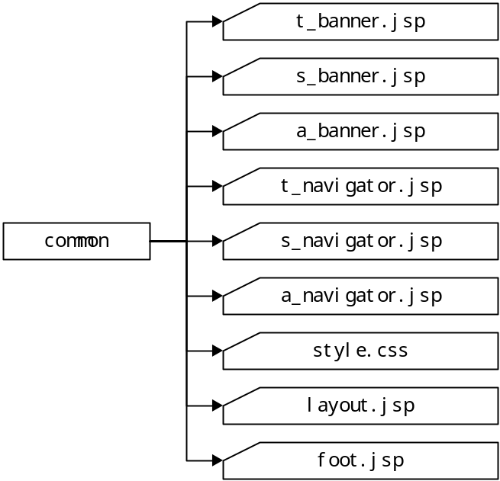

Architecture of eschooldoc directory
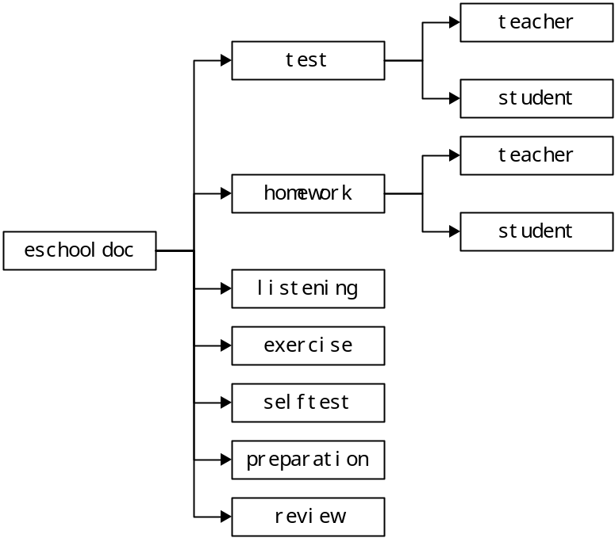

Architecture of tlds directory

Architecture of help directory
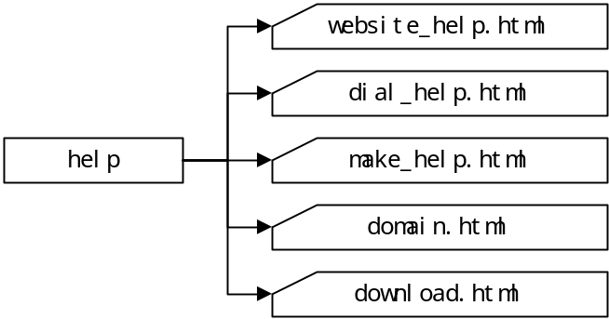

Contrast
Old Name | Contract Name | Path
T1 | t_home.jsp | /teacher
T2 | t_item_list.jsp | /teacher
T3 | t_test_detail.jsp | /teacher/test
T31 | question_list.jsp | /teacher/test
T32 | test_property.jsp | /teacher/common
T33 | data_upload.jsp | /teacher/common
T4 | other_item_detail.jsp | /teacher/others
T41 | other_item_list.jsp | /teacher/others
T5 | select_data.jsp | /teacher/common
T6 | answer_sheet.jsp | /teacher/test
T7 | judge_paper.jsp | /teacher/test
T8 | analyse_test.jsp | /teacher/test
T9 | t_lookup_grade.jsp | /teacher
T10 | approve_assignment.jsp | /teacher/others
T101 | upload_approved.jsp | /teacher/others
T102 | not_deliver.jsp | /teacher/others
 | t_test_title.jsp | /teacher/test/common
 | t_assignment_title.jsp | /teacher/others/common
 | t_others_title.jsp | /teacher/others/common
S1 | s_home.jsp | /student
S2 | s_item_list.jsp | /student
S3 | assignment_detail.jsp | /student/homework
S31 | assignment_list.jsp | /student/homework
S32 | upload_assignment.jsp | /student/homework
S4 | s_test_detail.jsp | /student/test
S5 | s_other_detail.jsp | /student/others
S51 | s_other_list.jsp | /student/others
S6 | s_lookup_grade.jsp | /student/test
P0 | eschool_login.jsp | /
P1 | lookup_data.jsp | /share
P2 | course_info.jsp | /share
P3 | personal_info.jsp | /share
P4 | website_help.html | /help
P5 | dial_help.html | /help
P6 | made_help.html | /help
P7 | domain_help.html | /help
P8 | download_help.html | /help
A1 | admin_home.jsp | /admin
A2 | user_list.jsp | /admin/user
A3 | user_manage.jsp | /admin/user
A4 | course_manage.jsp | /admin/course
A5 | select_student.jsp | /admin/course
A7 | course_list.jsp | /admin/course
A8 | admin_info.jsp | /admin/user
A9 | lookup_t_data.jsp | /admin/data
A10 | data_manage.jsp | /admin/data
A11 | sort_data_list.jsp | /admin/data
A12 | school_data_list.jsp | /admin/data
A13 | data_sort_manage.jsp | /admin/data
 | t_banner.jsp | /common
 | s_banner.jsp | /common
 | a_banner.jsp | /common
 | t_navigator.jsp | /common
 | s_navigator.jsp | /common
 | a_navigator.jsp | /common
 | foot.jsp | /common
 | layout.jsp | /common
 | style.css | /common
 | taglib.tld | /tlds

Tag List
No | Name of Tag | Depict
1 | courseListTag | 课程列表标签
2 | courseAttributeTag | 课程属性标签
3 | courseDetailTag | 某条课程详细信息标签
4 | testListTag | 考试列表标签
5 | testAttributeTag | 考试属性标签
6 | testDetailTag | 某条考试详细信息标签
7 | assignmentListTag | 作业列表标签
8 | assignmentAttributeTag | 作业属性标签
9 | assignmentDetailTag | 某条作业详细信息标签
10 | listeningListTag | 听力列表标签
11 | listeningAttributeTag | 听力属性标签
12 | listeningDetailTag | 某条听力详细信息标签
13 | selfscheduleListTag | 自习列表标签
14 | selfscheduleAttributeTag | 自习属性标签
15 | selfscheduleDetailTag | 某条自习详细信息标签
16 | exerciseListTag | 练习列表标签
17 | exerciseAttributeTag | 练习属性标签
18 | exerciseDetailTag | 某条练习详细信息标签
19 | reviewListTag | 复习列表标签
20 | reviewAttributeTag | 复习属性标签
21 | reviewDetailTag | 某条复习详细信息标签
22 | selftestListTag | 自测列表标签
23 | selftestAttributeTag | 自测属性标签
24 | selftestDetailTag | 某条自测详细信息标签
25 | subjectListTag | 科目列表标签
26 | subjectAttributeTag | 科目属性标签
27 | subjectDetailTag | 某条科目详细信息标签
28 | answerItemListTag | 答案列表标签
29 | answerItemAttributeTag | 答案属性标签
30 | answerItemDetailTag | 某条答案详细信息标签
31 | testResultListTag | 学生答题纸列表标签
32 | testResultAttributeTag | 学生答题纸属性标签
33 | testResultDetailTag | 某条学生答题纸详细信息标签
34 | scoreStatisticsListTag | 成绩统计列表标签
35 | scoreStatisticsAttributeTag | 成绩统计属性标签
36 | scoreStatisticsDetailTag | 某条成绩统计详细信息标签
37 | scorceListTag | 成绩列表标签
38 | scorceAttributeTag | 成绩属性标签
39 | scorceDetailTag | 某条成绩详细信息标签
40 | homeworkListTag | 作业列表标签
41 | homeworkAttributeTag | 作业属性标签
42 | homeworkDetailTag | 某条作业详细信息标签
43 | dataCellListTag | 资料列表标签
44 | dataCellAttributeTag | 资料属性标签
45 | dataCellDetailTag | 某条资料详细信息标签
46 | userListTag | 用户列表标签
47 | userAttributeTag | 用户属性标签
48 | userDetailTag | 某条用户详细信息标签
49 | schoolResourceListTag | 学校资源列表标签
50 | schoolResourceAttributeTag | 学校资源属性标签
51 | schoolResourceDetailTag | 某条学校资源详细信息标签

